Partial Differential Equation Exercises

Each of these exercises involves fundamental methods in solving PDEs, including the method of characteristics, separation of variables, Fourier series, and the use of Green's functions.
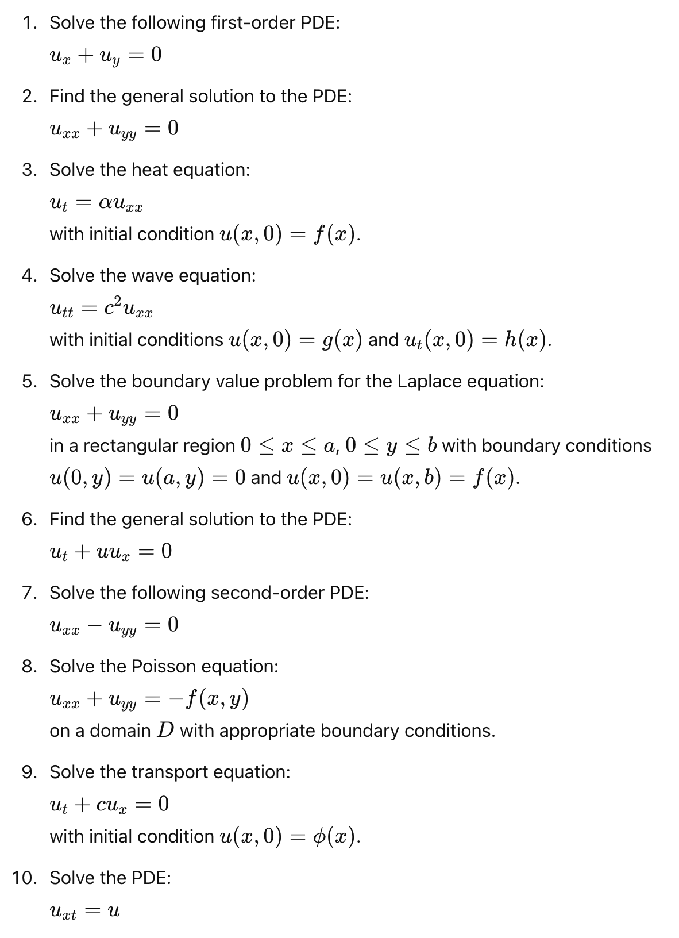

Hints for solving each exercise

- Hint: Try using the method of characteristics. Look for curves along which the PDE reduces to an ordinary differential equation (ODE).
- Hint: This is the two-dimensional Laplace equation. Consider using separation of variables to express the solution as a product of functions of x and y.
- Hint: Use the method of separation of variables and Fourier series to find the solution.
- Hint: Use D’Alembert’s solution for the wave equation.
- Hint: Use separation of variables and Fourier series to solve the problem.
- Hint: This is a first-order nonlinear PDE known as the inviscid Burgers' equation. Use the method of characteristics.
- Hint: This is the two-dimensional wave equation in steady-state form. Use separation of variables to find the solution.
- Hint: Consider using Green’s function or the method of separation of variables if the domain is simple.
- Hint: The method of characteristics will reduce the PDE to an ODE.
- Hint: Use the method of separation of variables to find a product solution
u(x, t)=X(x)T(t).

